Python Lab
Name-Siddhi Sanjay Chavan Roll no-262271022
Division-Beta Date-

Experiment no -1
Aim- Study and Implement the python Implememntation
Q 1]Study and Implement the python Implememntation, IDE ?
Solution-
1.Search for Anaconda download click on Anaconda Navigator.
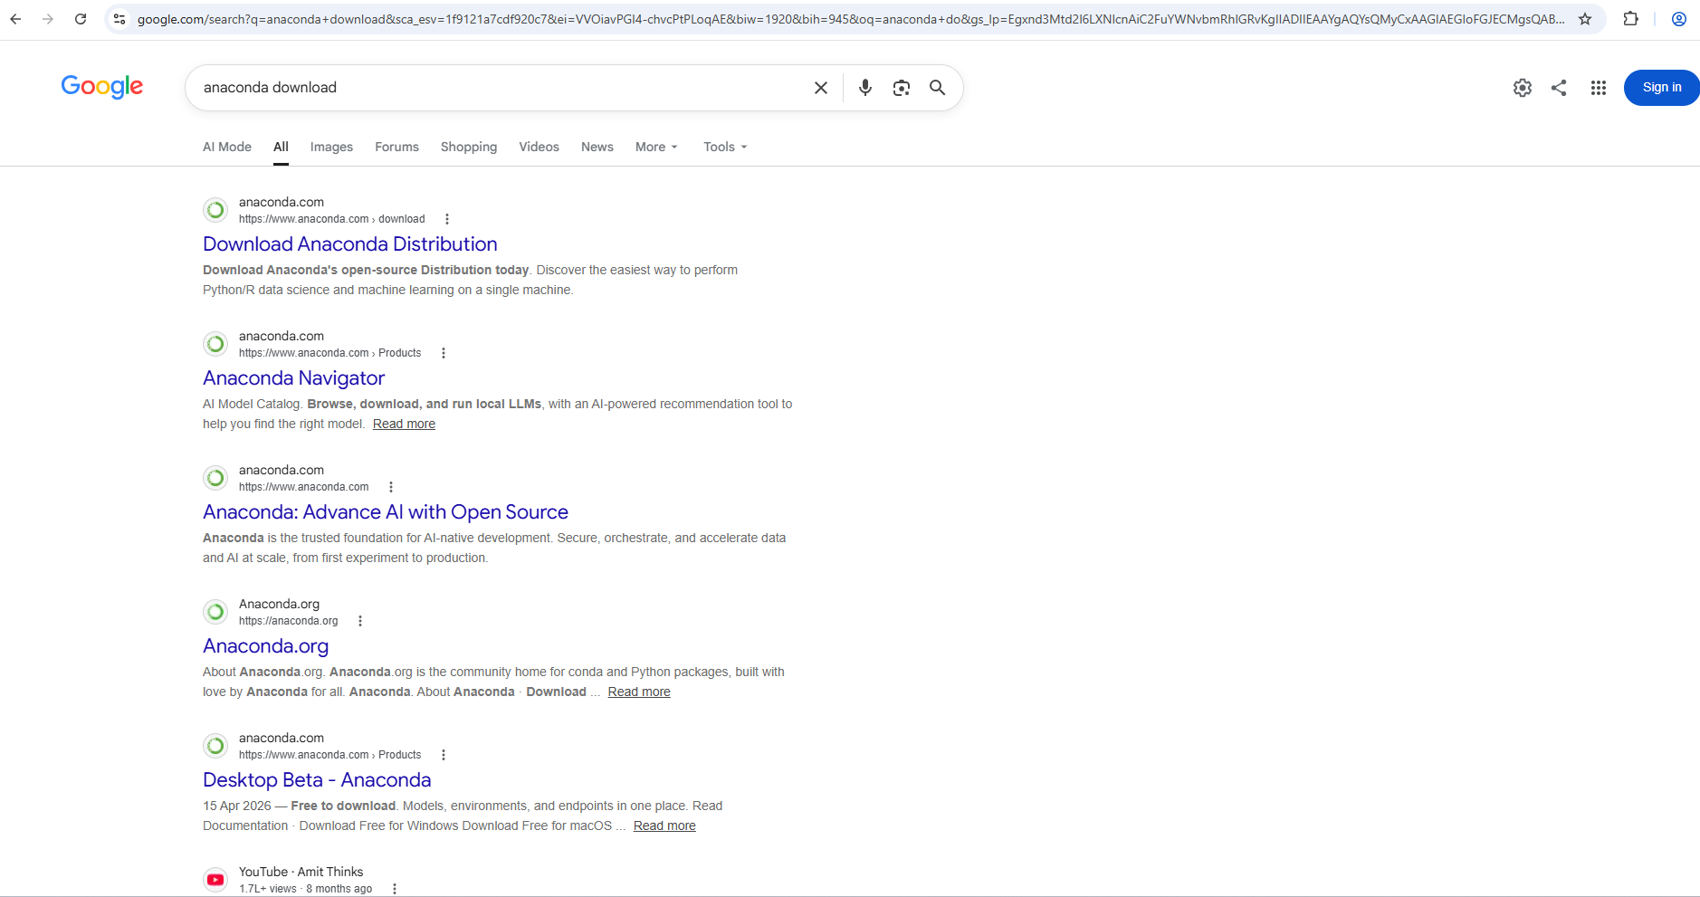
2.Click on Download now

3.Click on Skip Registration option
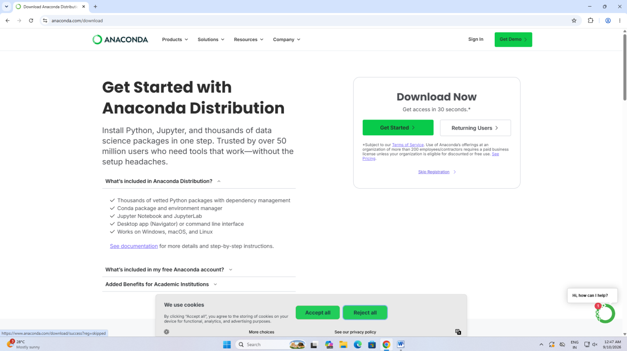
4.Windows ->Anaconda Distribution->Click Windows 64-Bit Graphical Installer
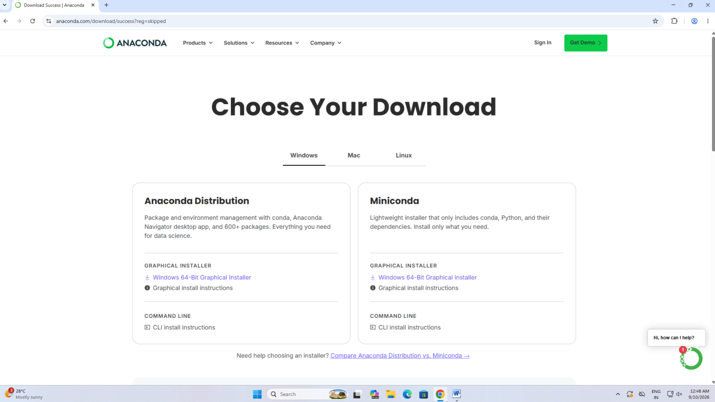

5.After Download click on exe file
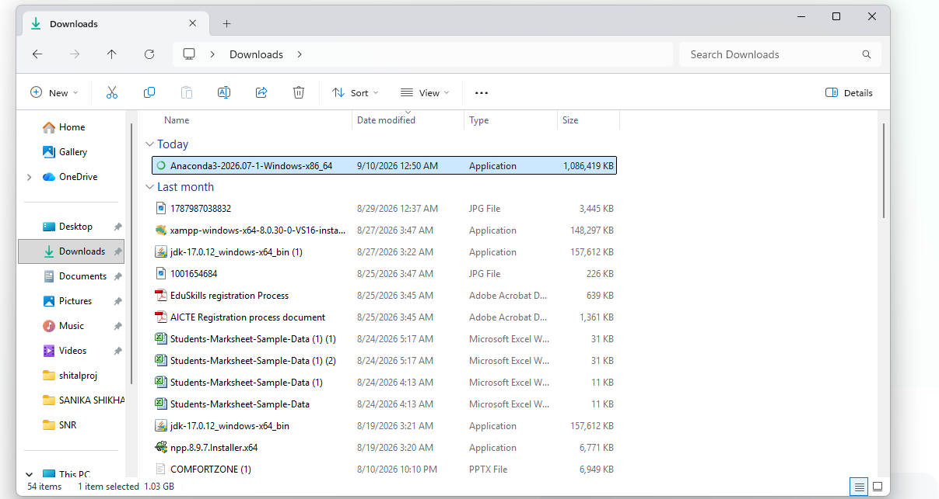
6.Click Next>
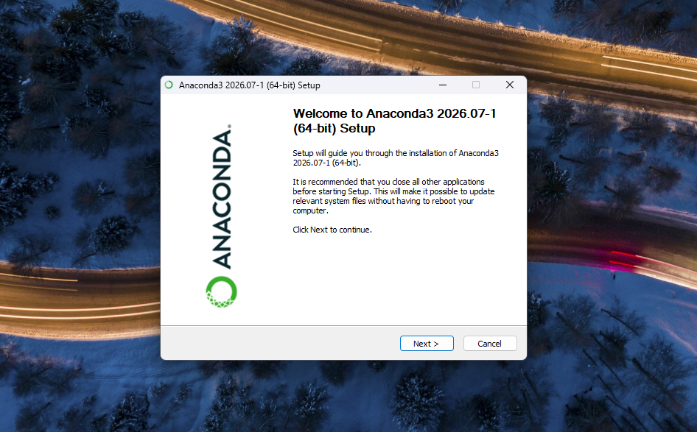

7.Click I Agree
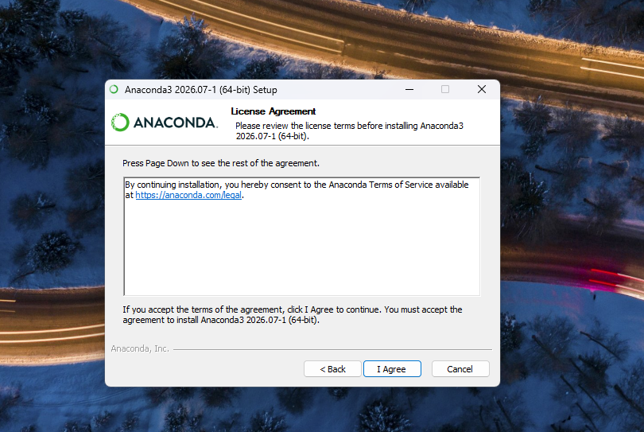
8.Click Next>
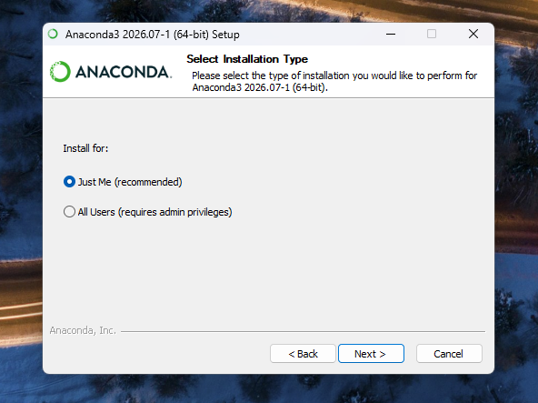

9.Click Next>
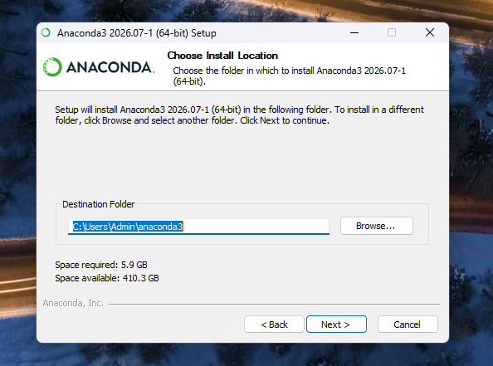
10.Click Install
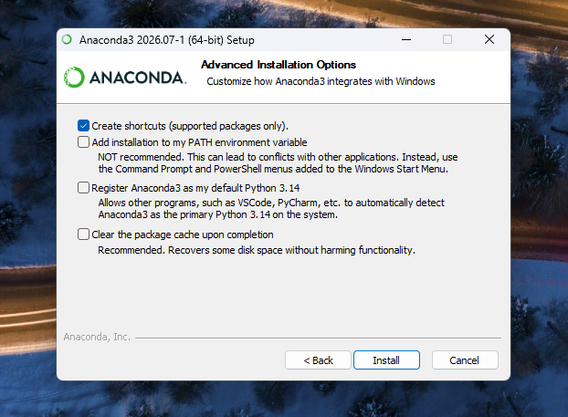

11.Installing process
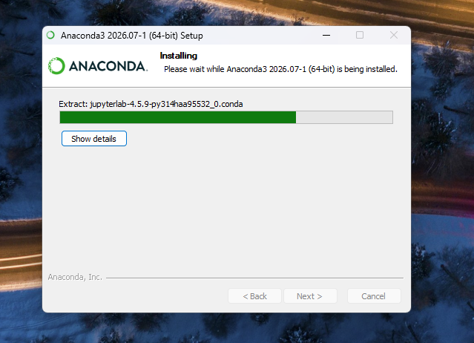
12.Installation Complete Click->Next
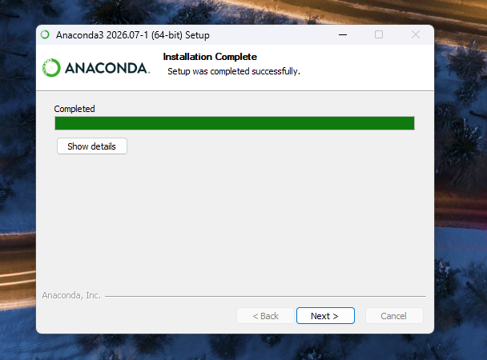

13.Click Next>
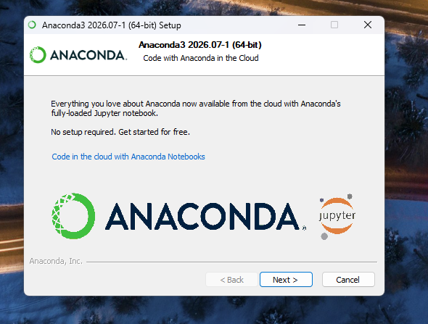
14.Click Finish
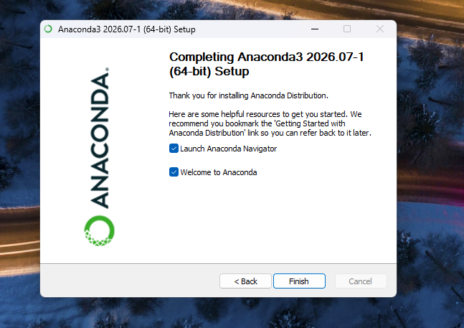
15.Anaconda Home page
16.Launch jupyter Notebook
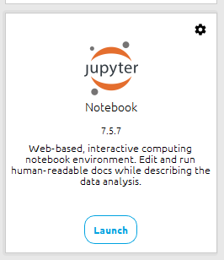

17.
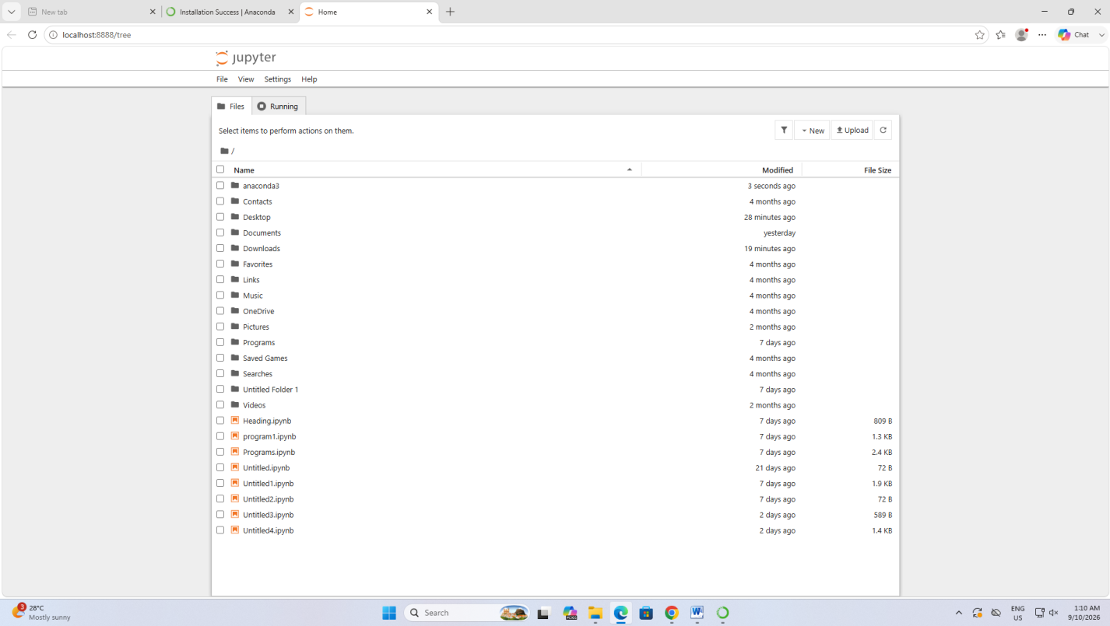
18.Click on new->python 3(pykernel)
- If you want to create New Folder simply click on New Folder
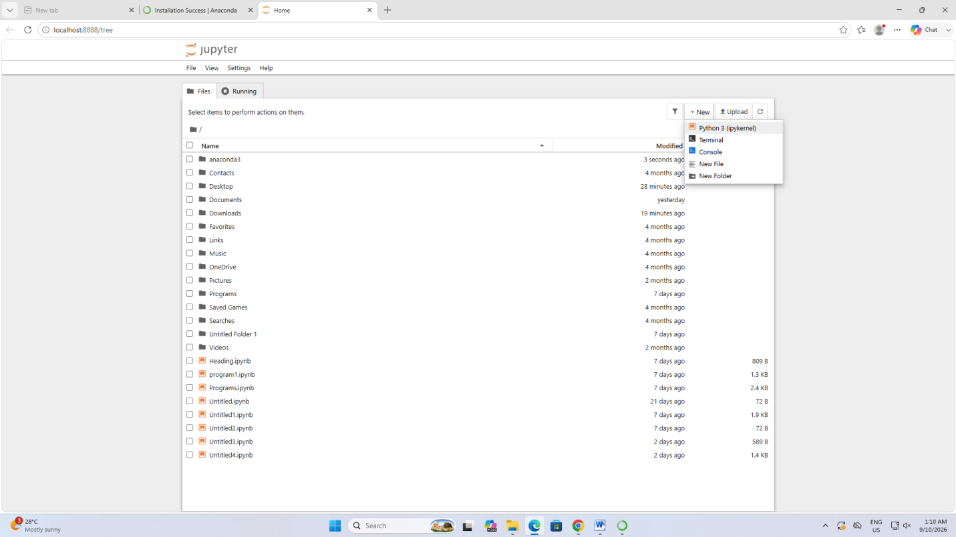

19.Here we can write python program(code)
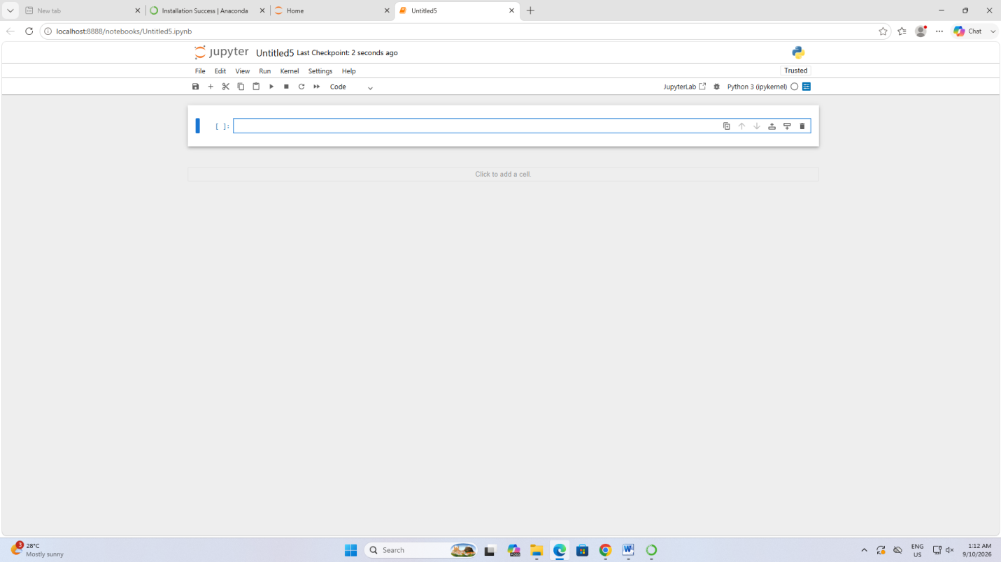
20.Hello world program
- Click on Untitled5 and rename file
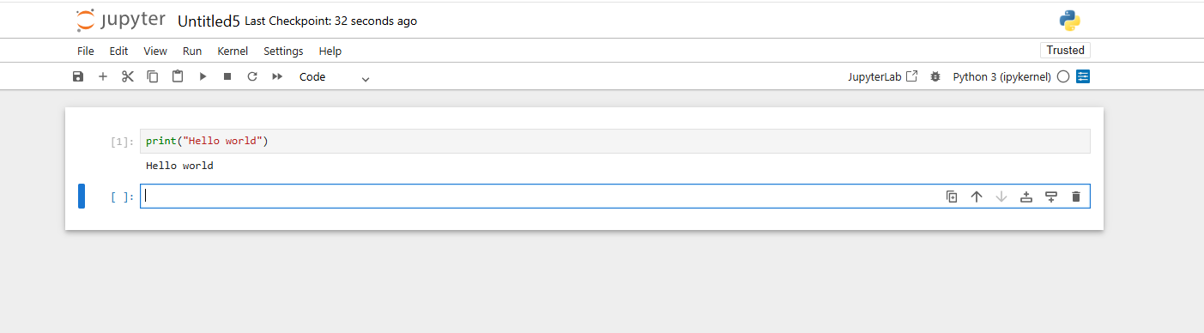

Experiment no 2
Aim- Python Program to Demonstrate Variables, Standard Datatypes, Input/Output, Type Conversion and Operators

Q1] Python Program to Demonstrate Variables, Standard Datatypes, Input/Output, Type Conversion and Operators
1. Variables and Standard Data Types
name = "Rahul" # String
age = 20 # Integer
height = 5.8 # Float
is_student = True # Boolean
subjects = ["Python", "Math", "Science"] # List
marks = (80, 75, 90) # Tuple
student = {"name": "Rahul", "age": 20} # Dictionary
colors = {"Red", "Blue", "Green"} # Set

print(name)
print(age)
print(height)
print(subjects)
print(marks)
print(student)
print(colors)
Output –
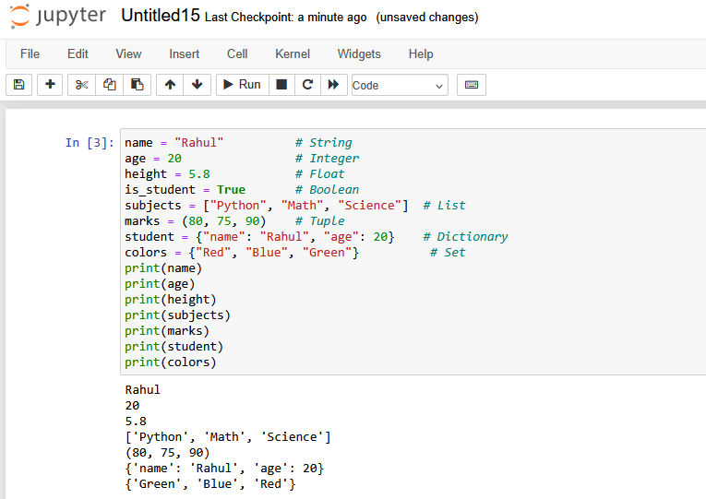
2. Arithmetic Operators / Input and Output
num1 = input("Enter first number: ")
num2 = input("Enter second number: ")

print("Addition:", num1 + num2)
print("Subtraction:", num1 - num2)
print("Multiplication:", num1 * num2)
print("Division:", num1 / num2)
print("Floor Division:", num1 // num2)
print("Modulus:", num1 % num2)
print("Exponent:", num1 ** num2)
Output –
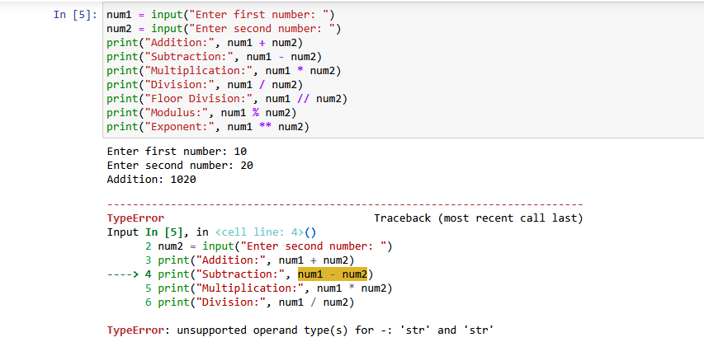
3. Relational Operators
num1 = input("Enter first number: ")
num2 = input("Enter second number: ")

print("num1 == num2:", num1 == num2)
print("num1 != num2:", num1 != num2)
print("num1 > num2 :", num1 > num2)
print("num1 < num2 :", num1 < num2)
print("num1 >= num2:", num1 >= num2)
print("num1 <= num2:", num1 <= num2)
Output –
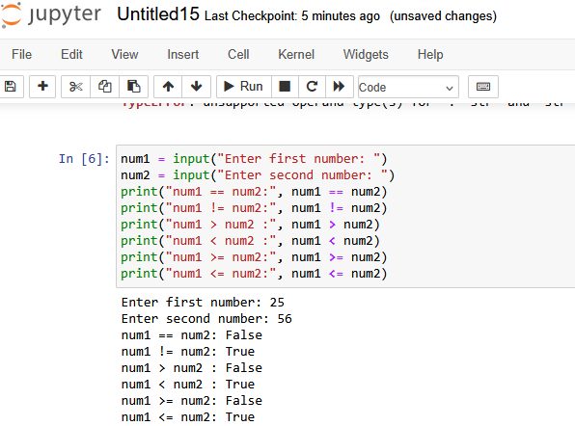
4. Membership and Identity Operators
subjects = ["Python", "Math", "Science"]

print("'Python' in subjects:", "Python" in subjects)
print("'English' in subjects:", "English" in subjects)
print("'English' not in subjects:", "English" not in subjects)

a = [1, 2, 3]
b = a
c = [1, 2, 3]

print("a is b:", a is b)
print("a is c:", a is c)
print("a is not c:", a is not c)
Output –
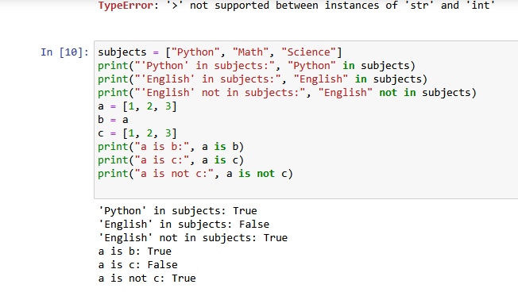

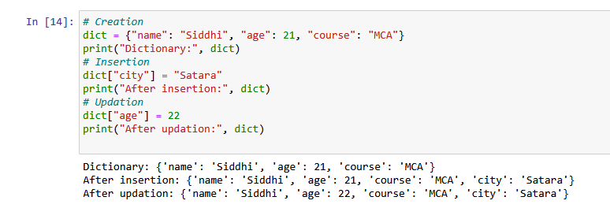

Experiment no-3
Aim- write program to demonstrate decision making statement and looping constructs by finding largest of three number generating the fibonacci series,and calculating the factorial of a given number.

# 1. largest of three numbers
a = int(input("Enter first number: "))
b = int(input("Enter second number: "))
c = int(input("Enter third number: "))

if a >= b and a >= c:
largest = a
elif b >= a and b >= c:
largest = b
else:
largest = c

print("Largest number =", largest)

# 2. Fibonacci series
n = int(input("\nEnter the number of Fibonacci terms: "))
if n < 0:
print("Please enter a non-negative number.")
else:
first, second = 0, 1
print("Fibonacci series:")

for i in range(n):
print(first, end=" ")
first, second = second, first + second
print()

# 3. factorial of a number
num = int(input("\nEnter a number to find factorial: "))

if num < 0:
print("Factorial is not defined for negative numbers.")
else:
fact = 1
i = 1

while i <= num:
fact = fact * i
i += 1

print("Factorial of", num, "=", fact)

output:
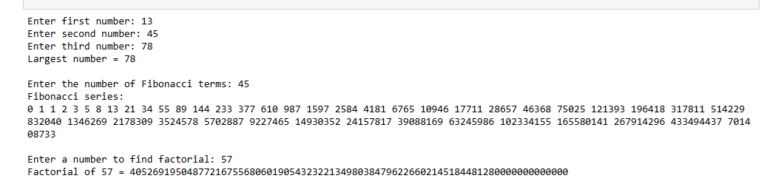

Experiment no-4
Aim- Write a python programm to check weather the number is prime, Armstrong or palindrome
Q3]Write a python programm to check weather the number is prime, Armstrong or palindrome
_{solution-}
_{1 .prime number}
n = int(input("Enter a number: "))

if n > 1:
for i in range(2, n):
if n % i == 0:
print("Not a Prime Number")
break
else:
print("Prime Number")
else:
print("Not a Prime Number")
output-
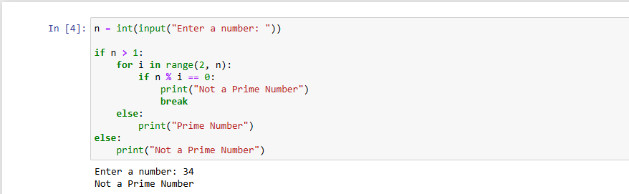
2. Armstrong Number
n = int(input("Enter a number: "))

temp = n
sum = 0
digits = len(str(n))

while temp > 0:
digit = temp % 10
sum = sum + digit ** digits
temp = temp // 10

if n == sum:
print("Armstrong Number")
else:
print("Not an Armstrong Number")
output-

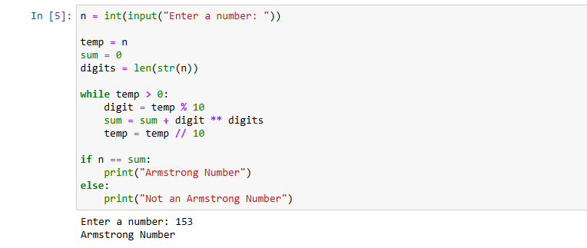
3. Palindrome Number
n = int(input("Enter a number: "))

temp = n
rev = 0

while temp > 0:
digit = temp % 10
rev = rev * 10 + digit
temp = temp // 10

if n == rev:
print("Palindrome Number")
else:
print("Not a Palindrome Number")

output-
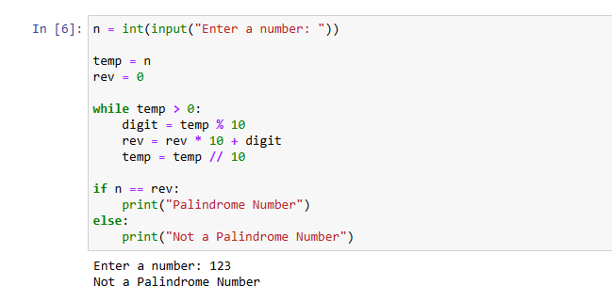

Experiment no-5
Aim- Operations covered: creation, insertion, updation, deletion, searching and traversal for List, Tuple, Set and Dictionary.

Q4] Python Program to Perform Operations on Standard Data Types
Operations covered: creation, insertion, updation, deletion, searching and traversal for List, Tuple, Set and Dictionary.
1. LIST
# Creation
my_list = [10, 20, 30, 40]
print("Creating List:", my_list)

# Insertion
my_list.append(50)
print("After insertion:", my_list)

# Updation
my_list[1] = 25
print("After updation:", my_list)

# Searching
if 30 in my_list:
print("30 is found in the list")

# Deletion
my_list.remove(40)
print("After deletion:", my_list)

# Traversal
for item in my_list:
print(item)
Output –
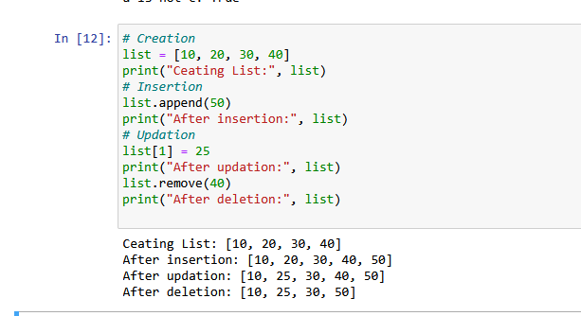
2. TUPLE
# Creation
my_tuple = (10, 20, 30, 40)
print("Tuple:", my_tuple)

# Searching
if 20 in my_tuple:
print("20 is found in the tuple")

# Traversal
for item in my_tuple:
print(item)

# Deletion of the complete tuple
del my_tuple
Note: Tuple is immutable, so individual elements cannot be inserted, deleted or updated.
Output – Tuple
Tuple: (10, 20, 30, 40)
20 is found in the tuple
10
20
30
40
3. SET
# Creation
my_set = {10, 20, 30, 40}
print("Set:", my_set)

# Insertion
my_set.add(50)
print("After insertion:", my_set)

# Updation
my_set.remove(20)
my_set.add(25)
print("After updation:", my_set)

# Searching
if 30 in my_set:
print("30 is found in the set")

# Deletion
my_set.remove(40)
print("After deletion:", my_set)

# Traversal
for item in my_set:
print(item)
Output – Q2, Set Snip
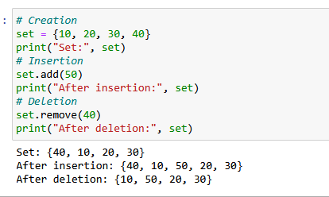
4. DICTIONARY
# Creation
my_dict = {"name": "Siddhi", "age": 21, "course": "MCA"}
print("Dictionary:", my_dict)

# Insertion
my_dict["city"] = "Satara"
print("After insertion:", my_dict)

# Updation
my_dict["age"] = 22
print("After updation:", my_dict)

# Searching
if "name" in my_dict:
print("Name is found in the dictionary")

# Deletion
del my_dict["city"]
print("After deletion:", my_dict)

# Traversal
for key, value in my_dict.items():
print(key, ":", value)
Output –

Experiment no 6

Aim- Write a python programm to perform string operations

Program
text = input("Enter a string: ")
# Reverse the string
print("Reversed:", text[::-1])

#Concatination of string
a=input("Enter string: ")
print("Concatination:",(text+a))

#substring
print( "Substring")
s=input("Enter string: ")
s1=s[:4]
print(s1)

output-

`